Intermediate Level
Musical Skills
For
ONE
Band
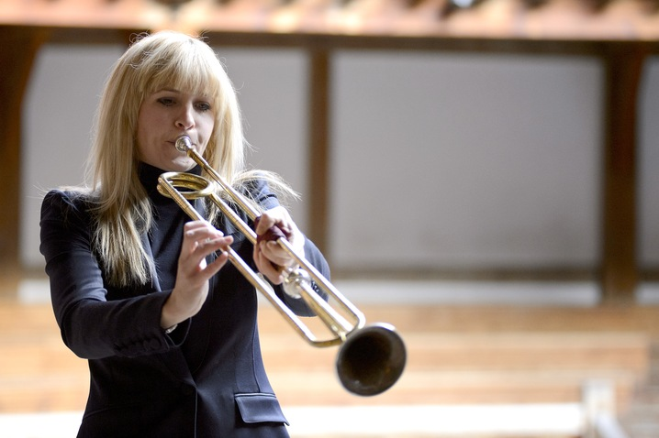
This list focuses on some things which you might overlook. At this level judgment becomes as important as technical skills. Ask Brian, your music teacher, your peers, or the internet for help.
Guitar and Piano
- chords Eb B^{b}m
- Basic jazz chord substitutions and modern Celtic chord substitutions.
- Improvising a doina (solo) in E Freygish and general improvisation skills.
All Wind Players
- Tuning, tone blending and phrase matching.
- Volume control.
- Trading solos, leads and fills with others including with vocalists.
Lower Brass /Bass skills
- Bass runs in all chords and scales.
- Judgment and courage in introducing awesome bass lines.
Fiddle Skills
- Tuning, tone blending and phrase matching.
- Dance playing endurance skills.
- Develop a sophisticated knowledge of traditional fiddle styles.
Vocal Skills
- Develop a sophisticated knowledge of traditional vocal styles present in our community.
- Learn to connect with an audience and encourage them to sing.
Percussion Skills
- Develop a sophisticated knowledge of traditional and contemporary percussion styles present in our community.

Brian Perkins Music
12 Decatur Street
Burlington VT 05401
brianperkinsmusic.com
brianperkins2002@yahoo.com
802-881-8500

